An In-Depth Look at the Transformer Based Models
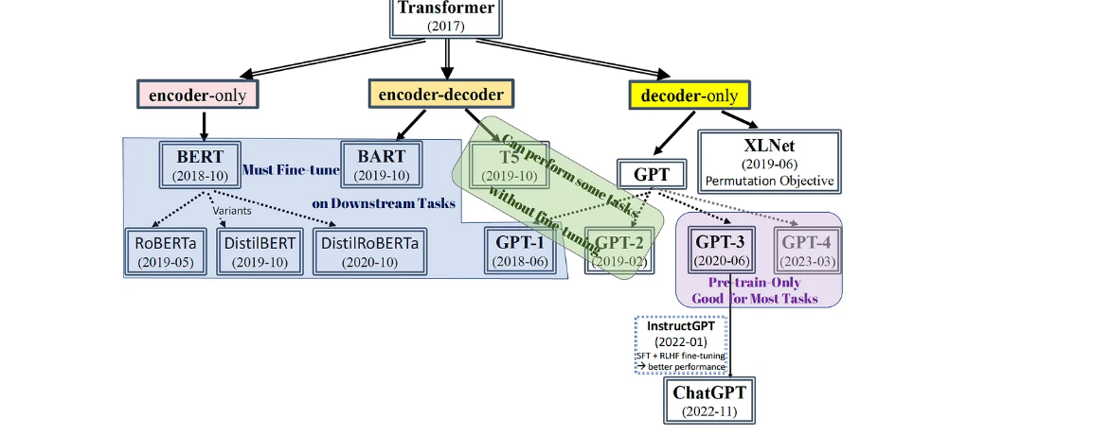

Fig. 1: Transformer-based models graph. The graph illustrates models of different architectures — encoder-only (autoencoding AE), decoder-only (autoregressive AR), and encoder-decoder models, and whether they require fine-tuning on downstream task-specific datasets. (Image Source: created by auth

BERT, GPT, T5, BART, and XLNet are members of the Transformer (Vaswani, et al., 2017) family. These models leverage either the Transformer’s encoder, decoder, or both for language understanding or text generation. Since 2018, Transformer models have successfully superseded traditional LSTM and CNN networks in natural language processing tasks.
In contrast to BERT, which employs the encoder, the GPT models (GPT-1 to GPT-4) have mostly remained the same architecture utilizing Transformer decoder stacks. The variances in architecture and pre-training objective among language models determine whether a model excels in text generation task or language understanding task. We will examine each Transformer-based model individually. However, first, I will introduce some critical fundamentals such as architectures, pre-training objectives, tokenizers, and positional encodings, which vary across models and are responsible for their distinct strengths and weaknesses in solving different natural language tasks.

Though decoder-only LLMs (GenAI) are incredibly powerful, they come with certain limitations. Fine-tuning or training an upscaled LLM is time-consuming and isn’t a panacea

OUTLINE

1. Critical Fundamentals
··· 1.1 Architecture
········ Encoder-Based
········ Decoder-Based
········ Transformer-XL (Improved Transformer)
··· 1.2 Pre-Training Objective
········ Pre-training Process (must)
········ Fine-tuning on downstream tasks (must or not? — depends on objective)
··········· Autoencoding (AE) — Denoising Objective
··········· Autoregressive (AR) — Seq-to-Seq Objective
··········· Permutation Autoregressive Objective (AR variant, XLNet uses)
··· 1.3 Positional Encoding
········ Absolute Positional Encoding
········ Relative Positional Encoding (short introduction)
···1.4 Tokenizer (sub-word level)
········ WordPiece (short introduction)
········ Byte-Pair-Encoding (BPE) (short introduction)

2. Models
··· 2.1 BERT
········ RoBERTa
········ DistilBERT
········ DistilRoBERTa
··· 2.2 GPT
········ GPT-1 (must fine-tuning)
········ GPT-2 (some in-context learning ability)
········ GPT-3 (phenomenal in-context learning; ChatGPT = pre-trained GPT-3 + fine-tuned by InstructGPT method )
··· 2.3 T5
··· 2.4 BART
··· 2.5 XLNet

3. Conclusions

1. Motivation of LLM-Based Agents
··· 1.1 Why Not Fine-Tuning?

2. What is an agent?
··· 2.1 A gentle introduction of generic agents
··· 2.2 What is an LLM-based agent?
··· 2.3 Critical Components

1. Critical Fundamentals

1. 1 ARCHITECTURE
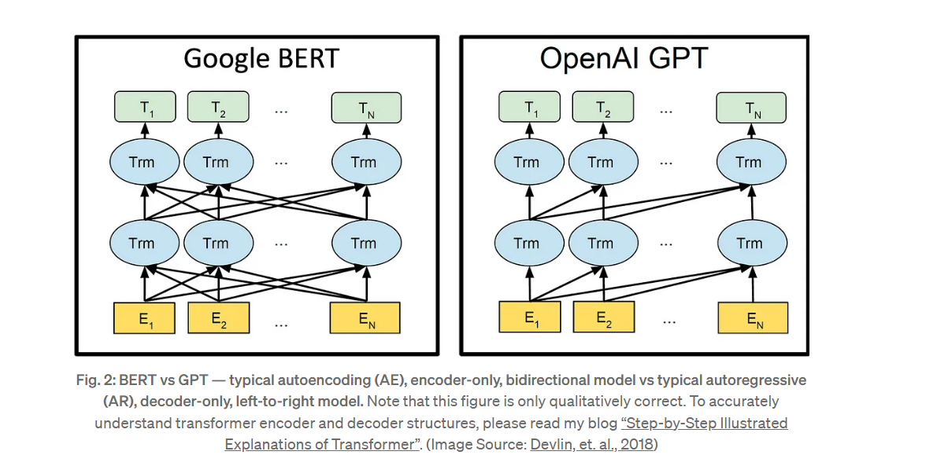

Transformer was an encoder-decoder neural network with a core component — self-attention mechanism. (Please refer to my blog “Step-by-Step Illustrated Explanations of Transformer” for an in-depth understanding of the self-attention mechanism. ) The encoder performs parallel processing on all tokens, allowing for bidirectional understanding, while the autoregressive output text generation nature of the decoder limits it to left-to-right processing. The choice to prioritize building upon the encoder block or the decoder block in the architecture is closely linked to the selection of pre-training objectives,
An improved version of the Transformer model, called Transformer-XL, was proposed in 2019 to address the issue of the extra-long dependency in context. The original Transformer-based models can only learn a fixed-length segment of 512–2048 tokens. When dealing with lengthy texts, learning multiple segments independently can lead to the inability to capture interdependencies between these segments. Transformer-XL incorporates a segment-level recurrence mechanism, which caches the previous segments in a hidden state to be reused as an extended context when processing the next segment. XLNet is just built upon the Transformer-XL architecture. Below are examples of models that use encoder-only, decoder-only, or both:
• Encoder-only Models: BERT;
• Decoder-only Models: GPT, XLNet (Transformer-XL, permutation);
• Encoder-Decoder Models: T5, BART.

1.2 PRE-TRAINING OBJECTIVE
A language model typically undergoes a two-step process:
(a). Pre-training: This establishes a decisive foundation for the model by training on huge and diverse text datasets (such as Wikipedia, question-answering websites, literature books, etc.) to establish a broad and upper-level understanding of natural language patterns in an unsupervised manner.
(b). Fine-tuning: The pre-trained model is further trained on lower-level, more specific downstream tasks separately, such as sentiment analysis, text classification, named entity recognition, machine translation, and question-answering, etc. However, the fine-tuning on downstream tasks requires the creation of carefully prepared datasets with corresponding labels and often involves modifying the fine-structure of the model, which demands significant labor force.

However, our ultimate goal is to unify all downstream tasks into one solitary pre-training task, thus eliminating the need for any subsequent fine-tuning on separate tasks. Google introduced the T5 model in 2019, which treated all NLP tasks as text-generation tasks, even for text classification problems. Furthermore, GPT-3 demonstrated phenomenal in-context learning capability during the pre-training process only (Fig. 7 & Fig.8) and outperformed other fine-tuned models in certain downstream tasks.

The choice of pre-training objectives can significantly impact the performance of a Transformer-based model and the degree of adaptation required for fine-tuning on specific tasks. Autoregressive (AR) and autoencoding (AE) are currently two successful types of objectives. AR models focus on regenerating text sequences and are particularly skilled in text generation tasks such as machine translation, abstractive summarization and question-answering. AE models aim to reconstruct the original text from corrupted text data and excel in language understanding.
• Autoencoding (AE) models: BERT, BART, and T5;
• Autoregressive (AR) models: GPT;
• Permutation AR: XLNet (Section 2.5).

1.3 POSITIONAL ENCODING
Transformer-based models encode positional information by adding positional embeddings to token embeddings, ensuring parallel processing while preserving text sequence order. The original Transformer model used sinusoidal functions of absolute positions, with the insight that the relation between two tokens in different positions could be expressed as the cosine similarity of their positional embeddings.
However, Transformer-XL introduced relative positional encodings to handle position encodings in different segments and recognized that the distance between each pair of tokens is a more critical factor in self-attention calculations than their absolute positions. Rₛ represents the relative distance s between two positions and the vector Rₛ is trainable during self-attention calculations. More information on relative encoding can be found on page 5 of the Transformer-XL paper.
• Absolute Positional Encoding: BERT, GPT, BART,
• Relative Positional Encoding: T5, XLNet.

1.4 TOKENIZER
A token can be simply referred to as a single word or a sequence of consecutive words (n-grams). However, since English words have various inflectional forms (verb tenses, transition between verbs and nouns, plural, compound words, etc.) , sub-word based tokenization is a viable option as it breaks down a word into sub-word units to capture its as root, prefix, suffix and other linguistic elements. For instance, “tiresome” can be decomposed into “tire” and “some” , while “tired” can be broken down into “tire” and “d”. In this way, “tiresome” and “tired” can be recognized to have the same derivations.
Large language models (LLMs) commonly use sub-word tokenization, with two primary methods being WordPiece and Byte-Pair-Encoding (BPE). The WordPiece method collects sub-word units by maximizing the likelihood of the vocabulary dataset over all possible n-gram characters. On the other hand, BPE is similar to WordPiece but uses all 256 Unicode characters and thus can include special chracters and eliminate the need for adding a special symbol to represent punctuation. Here is a reference for detailed information of WordPiece and BPE.
• WordPiece: BERT, T5;
• Byte-Pair-Encoding (BPE): GPT-2, GPT-3, BART, RoBERTa.

2. MODELS

2.1 BERT (Bidirectional Encoder Representations from Transformers)

BERT (Bidirectional Encoder Representations from Transformers)

What is BERT?
BERT is a Transformer-based model developed by Google AI in 2018. It is designed to pre-train deep bidirectional representations from unlabeled text by jointly conditioning on both left and right context in all layers. This allows it to deeply understand the meaning of words based on their surrounding context.
- Paper: “BERT: Pre-training of Deep Bidirectional Transformers for Language Understanding” by Devlin et al., 2018

Architecture of BERT
BERT uses only the encoder part of the original Transformer architecture (from “Attention is All You Need”).

Key Features of BERT Base and Large:
Feature | BERT Base | BERT Large
Layers (Transformer blocks) | 12 | 24
Hidden size | 768 | 1024
Self-attention heads | 12 | 16
Parameters | ~110 million | ~340 million
BERT includes components like:
- Multi-head self-attention
- Positional encodings
- Layer normalization
- Feed-forward layers
- Residual connections

Tokenization in BERT
BERT uses a technique called WordPiece Tokenization, which breaks words into subword units.
Example:
- Input word: playing
- Tokenized: ["play", "##ing"]
BERT also adds special tokens:
- [CLS] at the beginning for classification tasks.
- [SEP] to separate sentences or mark sentence boundaries.

Pretraining Objectives of BERT
BERT is pretrained on large unlabeled corpora like Wikipedia and BookCorpus, using two main objectives:

1. Masked Language Modeling (MLM)
- Randomly masks 15% of tokens in the input and asks the model to predict them.
- Helps the model learn deep bidirectional context.
- Example:
  - Input: "The man went to the [MASK]"
  - Model predicts: "store"

2. Next Sentence Prediction (NSP)
- Given two sentences A and B, the model predicts if B is the actual next sentence that follows A.
- 50% of the time B is the next sentence, 50% of the time it’s a random sentence.
These two tasks help BERT learn both token-level and sentence-level understanding.

Fine-Tuning BERT
After pretraining, BERT can be fine-tuned on a wide range of tasks by just adding a small output layer.

Common Fine-tuning Tasks:
- Text classification (e.g., sentiment analysis)
- Question answering (e.g., SQuAD)
- Named Entity Recognition
- Text entailment
- Paraphrase detection

Fine-tuning Process:
- Add a task-specific layer on top of BERT.
- Use a labeled dataset.
- Train all parameters of the model (not just the added layer).
- Typically trained for a few epochs (2–4) with a small learning rate.

Advantages of BERT
- Captures bidirectional context, unlike previous models (like GPT) that read only left-to-right or right-to-left.
- State-of-the-art performance on 11 NLP tasks at the time of its release.
- Transfer learning: BERT can be fine-tuned for many tasks with minimal data.

Limitations of BERT
- Large model size: Requires significant computational resources.
- Not ideal for real-time inference due to high latency.
- Static pretraining corpus: Does not adapt to changing world knowledge unless retrained.

Variants of BERT
- RoBERTa: Robustly optimized BERT with longer training and without NSP.
- DistilBERT: A smaller, faster version of BERT using knowledge distillation.
- ALBERT: A lite version with parameter sharing and reduced memory.
- TinyBERT, MiniLM: Lightweight versions for edge devices.

Applications of BERT
- Search engines (e.g., Google Search)
- Chatbots
- Text classification
- Document retrieval
- Sentiment analysis
- Legal/medical document understanding

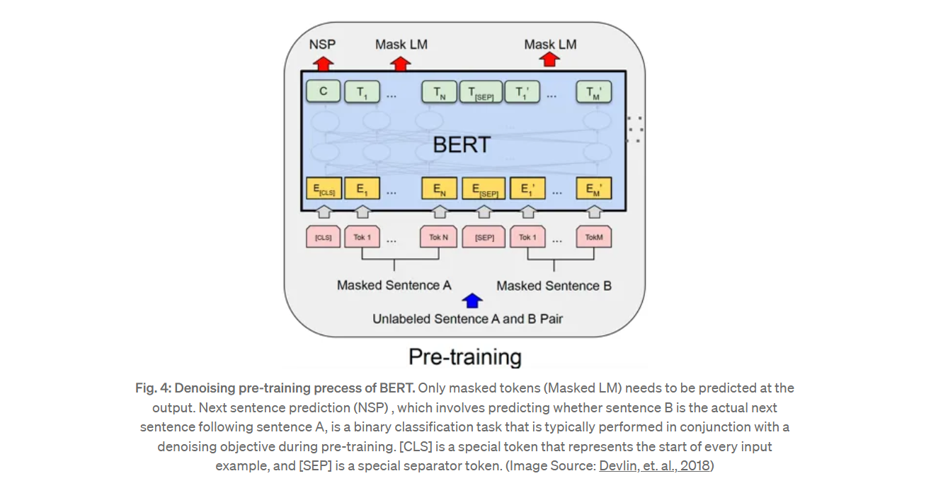

Variants of BERT
Several improved or specialized versions of BERT have been introduced to address limitations like training time, model size, or task performance. Below are the major BERT variants:

1. RoBERTa (Robustly Optimized BERT Approach)
- Developed by Facebook AI.
- Trained on more data and for longer periods.
- Removed the Next Sentence Prediction (NSP) task.
- Uses dynamic masking instead of static.
- Improved performance over original BERT on many benchmarks.

2. DistilBERT
- Created by Hugging Face.
- A compressed version of BERT using knowledge distillation.
- 40% smaller, 60% faster, and retains ~97% of BERT’s performance.
- Great for real-time and low-resource environments.

3. ALBERT (A Lite BERT)
- Developed by Google Research and Toyota Technological Institute.
- Shares parameters across layers to reduce memory usage.
- Replaces NSP with sentence-order prediction.
- Significantly fewer parameters with comparable or better performance than BERT.

2.2 GPT (Generative Pre-Training language model)
OpenAI proposed the GPT-1–4 models that only used decoder stacks, making them left-to-right autoregressive models. Although they do not have the same bidirectional understanding as BERT, their generative approach aligns well with downstream tasks, as all natural language tasks can be treated as generative tasks.
GPT-1 (2018, 117 million parameters) did not exhibit emergent capabilities and heavily relied on fine-tuning for individual downstream tasks. The figure below illustrates how downstream tasks are categorized into four categories and fine-tuned accordingly.
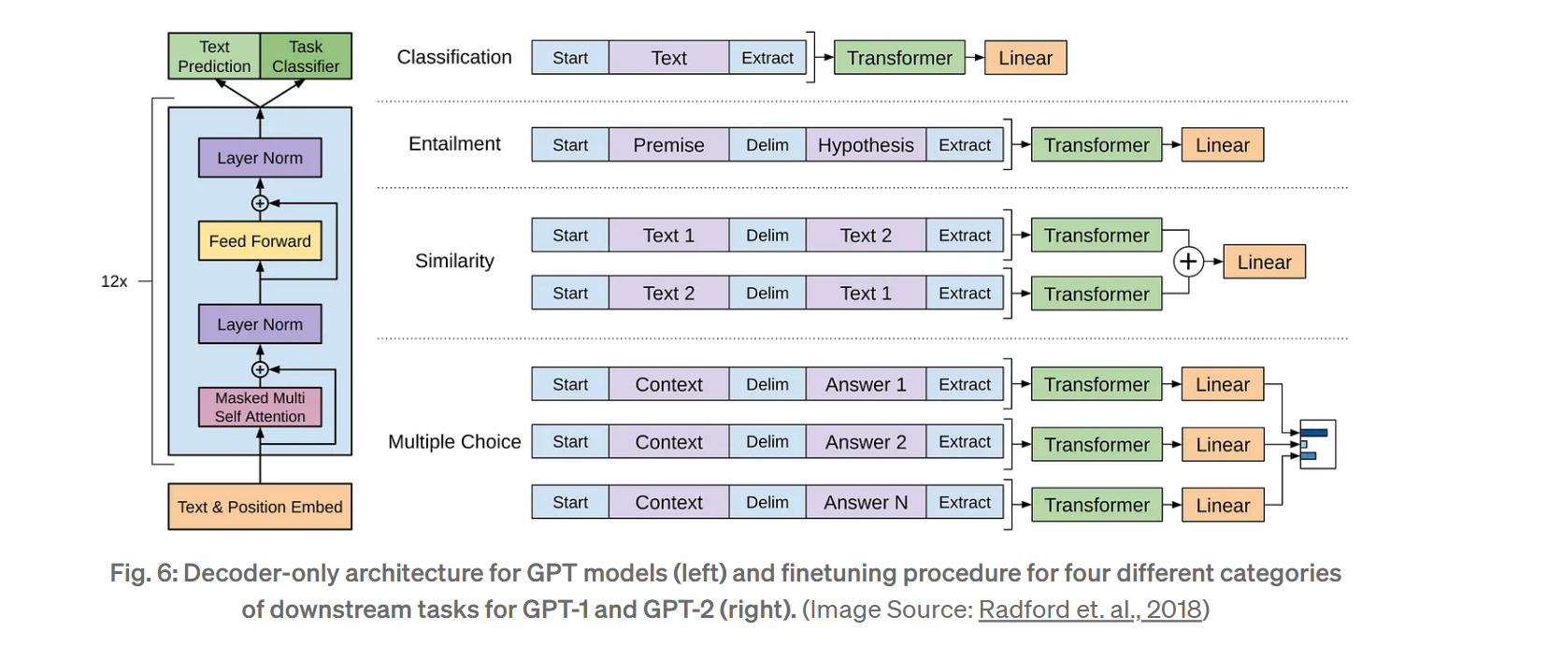

2.4 T5 (Text-To-Text Transfer Transformer)
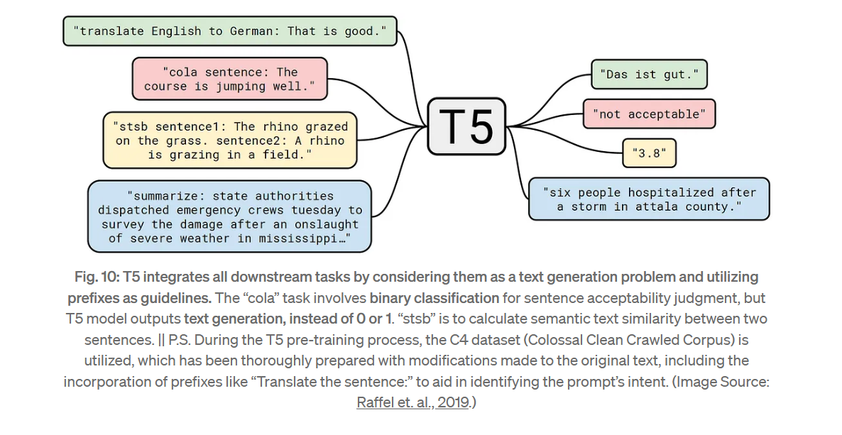
In 2020, Google proposed T5 as a unified model capable of transforming all downstream tasks into text generative tasks, even classification problems.
T5 uses an encoder-decoder architecture and a denoising objective, after experimenting with several unsupervised pre-training objectives and architectures. During pre-training, 15% of the tokens fed into the encoder are randomly masked. But it is a modified version of BERT’s masking and denoising algorithm: consecutive masked tokens are replaced by, a sentinel and are treated as a new single token added to the original vocabulary. This helps the model learn to predict how many words are missing in the blank. Later, generative capability is learned by randomly splitting the input text in the dataset, with the first part fed into the encoder and the second part treated as the output to be auto-regressively regenerated.

CONCLUSIONS
This article extensively covers Transformer-based models such as BERT, GPT, T5, BART, and XLNet. It focuses primarily on encoder or decoder-based architectures and pre-training objectives. The article reveals that autoencoder (AE) models excel in bi-directional context understanding. However, autoregressive (AR) models have an advantage in that there is less discrepancy between pre-training and fine-tuning downstream tasks. Additionally, when the model is scaled to a certain point, pre-trained models already exhibit comparable performance with state-of-the-art models for some tasks, without the need for further fine-tuning. Surprisingly, GPT-3 has demonstrated in-context learning abilities. It appears that AR models are the future, but XLNet attempts to combine the bidirectional context learning of AE models by proposing the permutation language modeling objective.

